GLUE 2.0 Specification (DRAFT)
Open Grid Forum Glue Schema Working Group [glue-wg]
Editors: Sergio Andreozzi (INFN), Balázs Kónya (Lund University)
Version: Draft 27/06/2007
Status of This Memo
This memo provides information to the Grid community about the definition of the GLUE schema version 2.0. This is an early draft and is expected to change considerably in the near future. Distribution is unlimited.
Copyright Notice
Copyright © Open Grid Forum (2007). All Rights Reserved.

1. Introduction
In this document, we present a conceptual information model for Grid entities described in natural language enriched with a graphical representation using the UML Class Diagram. As a conceptual model, this is meant to be implementation-independent. When a mature version will be available, mapping to concrete data models will be provided (e.g., relational, LDAP, XML Schema and RDF). From the semantic viewpoint, the concrete data model should represent the same concepts and relationships of the conceptual information model; nevertheless it can contains simplifications specific to the target data model in order to improve query performance or other aspects.
This information model is based on the experience of several modeling approaches being used in current production Grid infrastructures (e.g., GLUE Schema 1.x [glue-1.x], NorduGrid schema [ng-schema], Naregi model [naregi-schema], etc). The proposed initial collection of entities is motivated also by the use cases document [glue-usecases]. The properties listed for each entity are a temporary reallocation of those defined in the GLUE Schema 1.3 and NorduGrid schema (other schema can be considered in the next phase). They should not be considered as final and they will be revised in the next version by also adding the definition, unit of measure, data type and multiplicity. Besides the main entities this proposal currently contains well-defined entities for the Computing Element. For the Storage Element, there is only an initial UML Class Diagram, more details will be added in the next version.

2. Main Entities
- Site: Administrative domain grouping resources and services managed by the same set of person.
  - the administrative site can span different physical locations; the location attributes in this entity are meant to be used for the core location
  - NorduGrid does not have a site concept; there are administrative attributes in the resources; fine to add Site concept and move attributes there
  - properties: URI (ex-UniqueID), Name, Description, Contact (Email, Web page, ...), Location (Latitude, Longitude, ...?), Sponsor, OtherInfo
- Element: Grouping concept for services and the exposed resources where services and related resources have many to many relations; a service with no exposed resource is the simplest computing element.
    - it is introduced in order to capture the relationship among services managing or abstracting the access to resources
      - example of element composed by a single service: GridFTP server
      - the same resource can be shared across multiple services
        - e.g., SRMv1 and SRMv2.2 services on top of the same resource
        - e.g., CREAM and GRAM interface to the same batch system
      - the following specialization of the element entity are considered:
        - Computing
        - Storage
- Service: An abstracted, logical view of actual software components having a well-defined interface and offering one or more functionalities; it does have network endpoint(s); it abstracts some functionality.
  - the service entity will have extension hooks like key,value pairs or tag set
  - there will be the need to create service-specific schema . Tentative service specializations (types):
    - Computing: specialization of the service with additional information
    - Storage Management
    - File Transfer
    - ...
  - properties: URI (ex-UniqueID), Name, Type, Version, Endpoint, Status, StatusInfo, WSDL (?), Semantics, StartTime, Owner (?), AccessControlBaseRule (AuthorizationInfo), ServiceData=set of (Key,Value), Authentication (nordugrid-cluster-issuerca-hash, nordugrid-cluster-trustedca nordugrid-cluster-issuerca), SupportedProfile
- Resource: An entity that is useful in a Grid environment and offered through service(s). A resource usually represents aggregated information.
  - the following entities are considered (to be refined):
    - Computing
    - Storage (+ files)
    - Data
    - Network
    - Instrument
- Share: A utilization target for a set of resources defined by policies and characterized by status information.
  - the following specialization of the share entity are considered:
    - Computing
    - Storage
- Activity: An activity is a unit of work managed by a service; an activity can have relationships to other activities being managed by different services, therefore it shares a common context.
  - Grid jobs are example of activities for a Computing Service.
  - example of activity relationships (propagation):
    - Broker submits a grid job to a selected Execution Service, upon completion the Execution Service submits a logging record to a Accounting Service
- Virtual Organization: A virtual organization (VO) comprises a set of individuals and/or institutions having direct access to computers, software, data, and other resources for collaborative problem-solving or other purposes. (from OGSA Glossary).
  - Resources utilized by a VO are expected to be provisioned via SLA’s
  - The VO can exhibit the internal structure in terms of groups of individuals and/or institutions and their roles
- Policy: Statements, rules or assertions that specify the correct or expected behavior of an entity.
  - for example, an authorization policy might specify the correct access control rules to a share

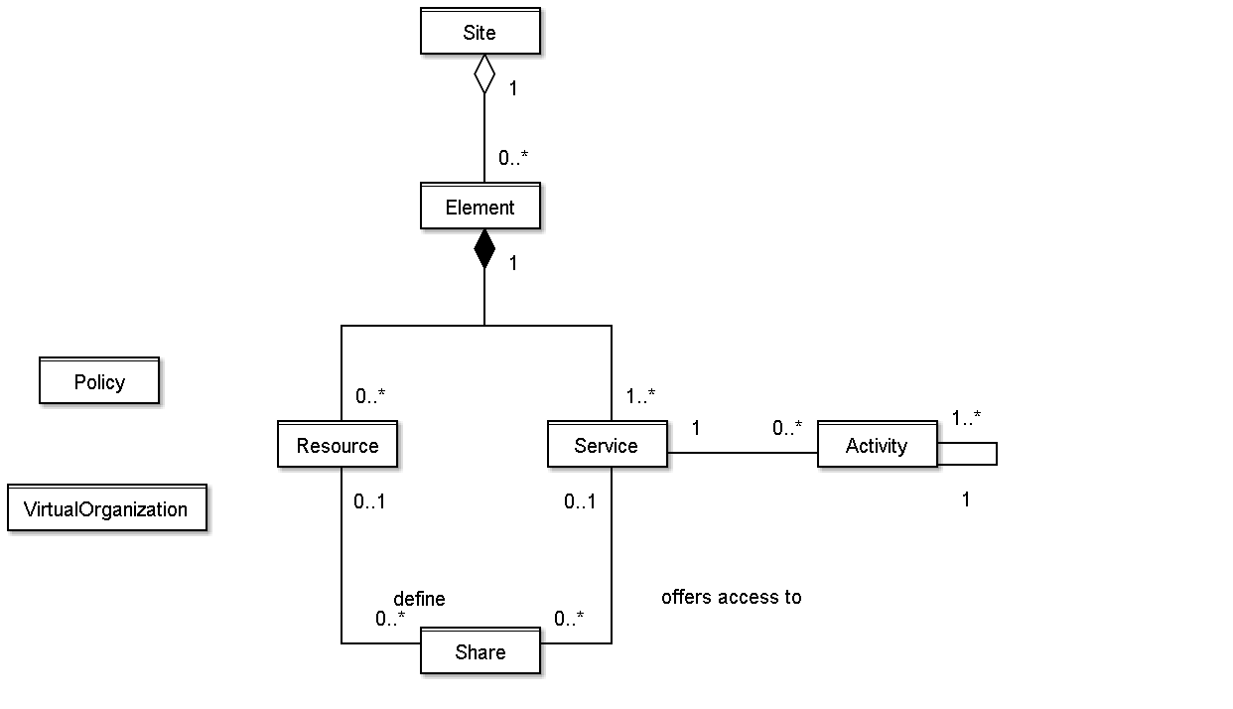
Figure 1: Glue 2.0 Main Entities and their relationships

3. Conceptual Model of the Computing Element
The conceptual model is based upon the main entities and uses specializations of Element, Resource, Share and Service entities. Further computing related concepts such as
Execution Environment, Application Environment, Job are introduced.
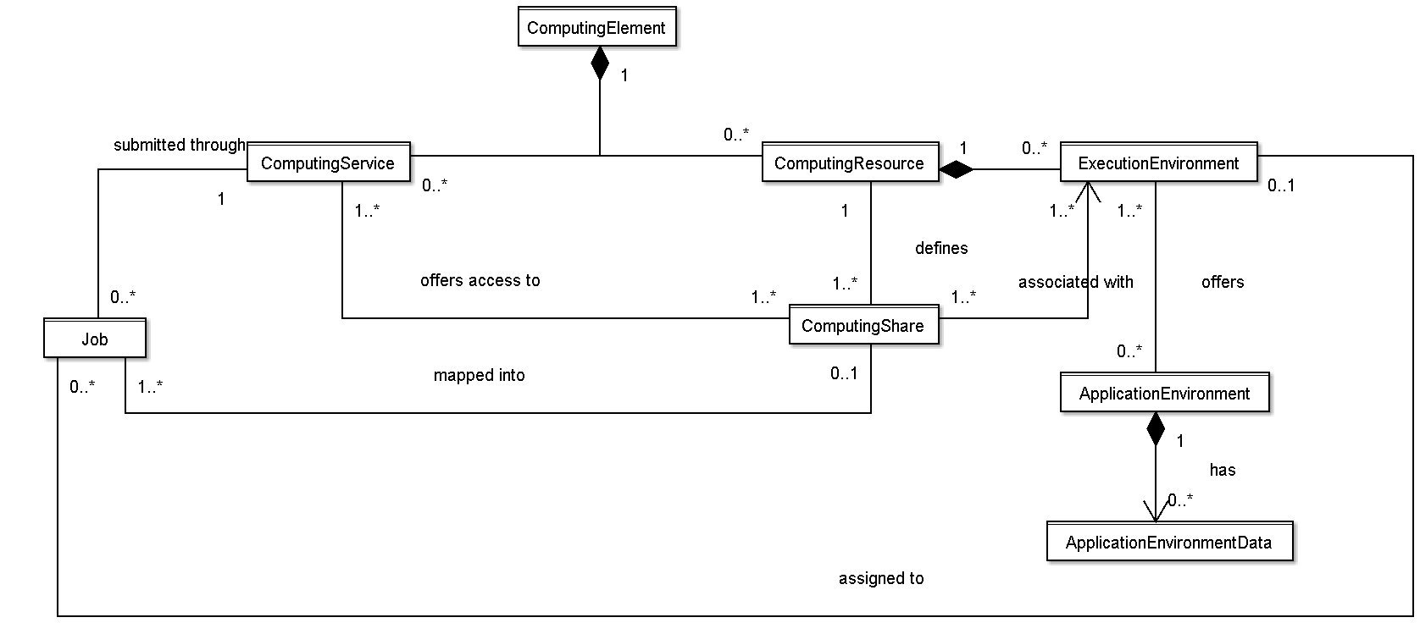

Figure 2: Entities and relationships for the Computing Element model
- Computing Element: Grouping concept for computing services and the exposed computing resources where services and related resources have many to many relations;
  - Examples
    - Service A exposes Resource A forming the simplest computing element
    - if a computing resource is exposed by many computing services, then these computing services are part of the computing element (Resource A exposed by Service A, B, C);
    - if a computing service exposes many computing resources, then these computing resources are part of the computing element (Service A exposes Resource A, B and C) ;
    - a computing element contains connected set of computing services and resources
      - Service A exposing Resource A and Service B exposing Resource B form two different computing elements
      - Service A exposes Resource A, Service B exposes Resource A and B form a computing element
  - Properties: URI, Name, LRMS(Type, Version, Note) (if the hypothesis that a CE maps to a set of resources managed by the same LRMS), nordugrid-cluster-support?, nordugrid-cluster-localse (similar to Glue.CESEBind.SEUniqueID), TotalJobs, RungningJobs, WaitingJobs, nordugrid-cluster-prelrmsqueued, nordugrid-cluster-owner, OtherInfo (e.g., to adversite a URL of a web page giving info about this element)
- Computing Resource: Grouping concept for a set of different types of execution environments; the aggregation is defined by the common management scope (e.g., a local resource management system like a batch system defines an aggregation scope); The OS can be the simplest case of LRMS. The Computing Resource may contain aggregated status information.
  - Properties: URI/LocalID (?), Total, Used, Physical/LogicalCPUs, Shared directories (e.g., TmpDir, ScratchDir, DataDir), Homogeneity, NetworkInfo (type of internal network available among the execution environments), Aggregated/Global Benchmark Info (?), CPUDistribution (number of boxes:number of CPUs, it can be repeated, e.g.: 1:16 3:2), nordugrid-cluster-sessiondir-free, nordugrid-cluster-sessiondir-total, nordugrid-cluster-cache-free, nordugrid-cluster-cache-total
- Execution Environment : A description of hardware and software characteristics that defines the environments available to and requestable by a Grid job when submitted to a Computing Service; the description also includes information about the total/available/used instances of the execution environment.
  - the software part is described by the Application Environment entity (besides the OS)
  - the execution environments can be of different types
    - a typical implementation of an execution environment is a computing node
    - a virtual machine image that can be requested by a job represents also a possible execution environment
      - different virtual machine images/execution environments can coexist on the same node
  - Properties: URI/LocalID (?), Type (e.g., virtualnode, realnode, smp, thread, multicore), LogicalUnitNumber (?), Total, Used, Unavailable, Physical/LogicalCPUs, CPU (Vendor, Model, Version, ClockSpeed, InstructionSet, OtherDescription), Memory (RAMSize, VirtualSize), OS (Name, Release, Version), Node benchmark (e.g., SPECInt2000, SPECfp2000), NetworkConnectivity (Inbound, Outbound), PlatformType (e.g., IA64),
- Application Environment: Description of the application software environment available within one or more execution environments.
  - it should be used also for application environments described in terms of a simple tag (like the attribute RunTimeEnvironment in GLUE 1.3)
  - properties: ID (URI, local, global, relative?), Catalogue/NameServer, Name, Version, Status (e.g.: tested, dynamic, installable), Lifetime, Bootstrapping (InstalledRoot, EnvironmentSetup, ModuleName), SoftwareData: (key,value)
- Computing Service: Specialization of service for creating, monitoring, and controlling computational activities called jobs.
  - properties: staging capabilities attributes, suspend capabilities
- Computing Share: A utilization target for a set of computing resources defined by policies and characterized by status information.
  - this is a specialization of the share concept applied to computing resources
  - a typical implementation of a share is via a batch queue with the associated policies and status information
  - the same share can be implemented using different batch system configuration/strategies
  - in complex batch systems, it is possible to define different set of policies for the same batch queue, this will imply a share for each set of policies
  - a share can be implemented by virtual machines management systems (to be extended)
  - the model supports heterogeneity by being able to represent different execution environments associated to the same share
  - properties: LocalID, Name, Max(WallTime, CPUTime, TotalJobs?, RunningJobs, WaitingJobs, nordugrid-cluster-prelrmsqueued, Memory, DiskSpace, SlotsPerJob, StageInStreams, StageOutStreams), Min (CPUTime, WallTime), Default (WallTime, CPUTime), preemption, priority?, authorization?, state (runningJobs, waitingJobs, totalJobs?, estimatedResponseTime, WorstResponseTime, freeJobSlots, Status?), meta-information (e.g., human-readable description, scheduling policy, comment), directory? (Data?, Application?), DefaultSE?, nordugrid-cluster-sessiondir-lifetime
- Job: An activity managed by a computing service.
  - it is typically described by an XML document compliant to the JSDL specification
  - at the moment, this entity refers to only a single job
  - need to model different types of jobs (e.g., single processor job, collection of jobs, workflows); a job type can be useful
  - some of the job attributes should possibly map the OGF usage record spec, JSDL and the BES activity attributes
  - important is the state model
  - it would be nice to have a timestamp-like information like (tag, timestamp), to be used for instance for status change info
  - properties: ID (globalID, localID, globalOwner, localOwner, nordugrid-job-jobname), Requests/Environment (nordugrid-job-reqwalltime, nordugrid-job-reqwalltime nordugrid-job-reqcputime, nordugrid-job-runtimeenvironment, nordugrid-job-cpucount, nordugrid-job-stdout nordugrid-job-stderr nordugrid-job-stdin), Status (nordugrid-job-comment, nordugrid-job-status, nordugrid-job-queuerank, nordugrid-job-rerunable, nordugrid-job-exitcode, nordugrid-job-errors, nordugrid-job-executionnodes, nordugrid-job-execcluster, nordugrid-job-execqueue, nordugrid-job-usedwalltime nordugrid-job-usedmem nordugrid-job-usedcputime, nordugrid-job-completiontime, nordugrid-job-submissionui, nordugrid-job-submissiontime, nordugrid-job-clientsoftware, nordugrid-job-gmlog, nordugrid-job-sessiondirerasetime, nordugrid-job-proxyexpirationtime)

4. Conceptual Model of the Storage Element
A preliminary UML figure is included below.
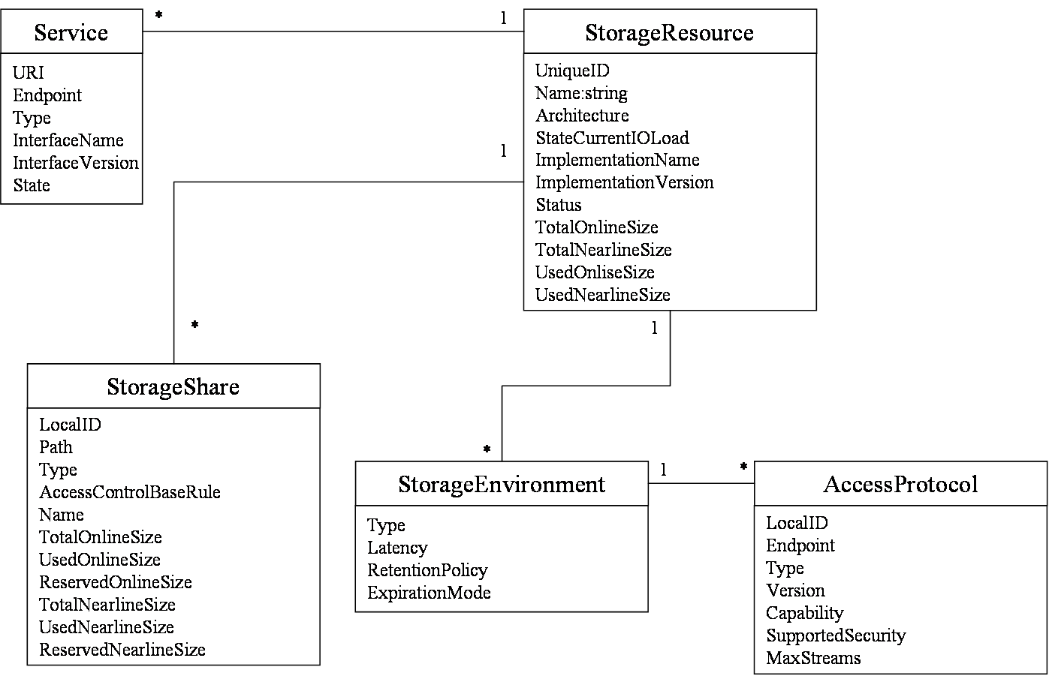
Figure 3: Entities and relationships for the Storage Element model. Very first sketch!

5. Collection of Questions and Open issues
This section serves as a placeholder for open issues, it will not be part of the document.
- static vs. dynamic attribute values
  - first, we should define what is static and dynamic
    - a possible improvement is to distinguish among configuration vs. monitoring
  - should static/configuration-related attribute be separated from dynamic attributes?
  - from time to time, people ask for that
    - pro: easier implementation
    - con: UML/Schema less readable and more complex
  - possible approach:
    - at the UML class diagram level, static vs. dynamic is not described by separation into different classes, but with annotations/tagged values
    - at the concrete data model level (relational, XMLSchema), static vs. dynamic can be considered in order to simplify the implementation
- do we need a common authorization entity?
  - such kind of info is needed in several classes and we should have a common way to define them and to relate them to the various classes
  - how would this relate to the share
- how to deal with extensibility?
  - in GLUE 1.3: tag-like approach: capability[*], (key,value)[*]
- In which entities and in which way we should display owner information?
  - Contact support and ownership information, is it enough to have it at the site level or should we have also at the "element" level?
- when reviewing the directory information in Computing Resource, consider the standardization activity on Grid job environment
- service and endpoint; in our modeling, does a service have only one endpoint or can have multiple endpoints?
  - if many endpoints, then we need per-endpoint information
  - in Web Services world, a service instance has a single endpoint;
  - this needs to be discussed
- how to deal with interactive jobs? where do we publish information about the service providing interaction with jobs? (a different service specialization together with the computing service?)
- policy information is part of services or resources?
- execution environments: how to deal with software packages that will be available only to certain VO's
- application environment:
  - can we improve the modeling when the application environment is available homogeneously to the whole computing resource?
  - what about if they are available to only a certain VO/set of VOs?
- computing share:
  - authorization policy vs. share
  - does this fully cover the concept of VOView of GLUE 1.3?
  - do we need priority in share? what is the use case for having them?
  - how to reflect policy on heterogeneous execution environment?
    - e.g., a share is associated to AMD and INTEL-based execution environment? do I want to be able to represent policy per type of execution environment? is it the trivial solution of splitting the share in two shares enough?
  - how to reflect authorization policies in the share? they should support not only VO's but also privilege attributes like one defined by VOMS
  - local vs. Grid job state information in shares (e.g., in nordugrid schema: nordugrid-queue-gridrunning nordugrid-queue-gridqueued nordugrid-queue-localqueued, nordugrid-queue-running)
  - status like production/draining/queuing/closed is per share or per service?
  - consider that waiting jobs can refer either to job waiting in the batch queue or in the front-end grid layer (e.g., during file staging); decide if the waitingJobs attribute refer to both or if we should add one more category (e.g. nordugrid-queue-prelrmsqueued )
    - this consideration also applies to MaxWaiting
  - in GLUE we have assignedJobSlots and maxRunningJobs; we believe that modeling only the max running is enough

6. References
[glue-wg] The Glue Working Group of OGF, https://forge.gridforum.org/sf/projects/glue-wg
[glue-usecases] Glue 2.0 Use Cases (early draft), https://forge.gridforum.org/sf/go/doc14621
[glue-1.x] The Glue Schema 1.3, https://forge.gridforum.org/sf/go/doc14185
[ng-schema] The NorduGrid/ARC Information System, NORDUGRID-TECH-4,https://forge.gridforum.org/sf/go/doc14273
[naregi-schema] NAREGI information and data model, https://forge.gridforum.org/sf/go/doc14300

